**HHD Seagate Brand**

PKR 6,100 Pro

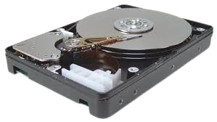

 hybrid hard drive (HHD), sometimes known as a solid-state hybrid drive (SSHD), is a mass [storage](https://www.techtarget.com/searchstorage/definition/storage) device that combines a conventional hard disk drive ([HDD](https://www.techtarget.com/searchstorage/definition/hard-disk-drive)) and a [NAND flash](https://www.techtarget.com/searchstorage/definition/NAND-flash-memory) module. An HHD blends the capacity, cost and performance of physical disk storage with the accelerated performance of flash.

Data that is frequently written to or retrieved from storage is served from [flash memory](https://www.techtarget.com/searchstorage/definition/flash-memory). Seagate Technology, Toshiba Corp. and Western Digital Corp.

**Type:** Internal

**Size:** 4.7"

**Speed:** 17000rpm

**Species:** 100GB

**Brand Name :** Seagate

**Application:** Server

**Cache capacity:** HHD

**Item Condition:** Fresh/New

**Shell Material:** Metal

**Products Status :** Good New